Rules of Engagement

I2CCDC v0.1

2023

Table of Contents

Rules 3

Using the Daily Duties Form: 4

Using the Justifications Form 5

***Disclaimer***

*Items on the Rules of Engagement may look slightly or extremely different from the images below or how they are described. If something is not clear, contact the operator of the competition or your instructor for clarification. DO NOT go into the competition without having read this and understood it fully. A copy of the signed document must be sent to your manager/boss as this is your agreed terms to work for the company.*

Welcome Competitors! If you are reading this, then you have been chosen! For what? The author of this is not entirely sure, but what they are sure of is that this will be stressful, yet fun, engaging, and interactive! So, thank you and welcome! Below you will find the rules of engagement for the competition. Should you have any questions or concerns, then do not hesitate to reach out to your designated point of contact.

# Rules

1. Teams may not use AI, but they are allowed to use the internet to research ways to harden the device or complete tasks.
2. Over the allotted timeframe, students are allowed to work within the specified environment by the operator. The rules below are intended as a foundation, and modifications may be made to them. It is the operator’s discretion on how rules are conveyed and distributed, it is the team’s responsibility to read and understand the rules.
3. Operators reserve the right to tamper with hardware during non-competition hours.
4. Only the team captain communicates with the manager & boss. Unless the manager or boss specifically requests an employee
5. Only team captains are to submit the daily duties & justification reports
   1. Team captains have the ability to designate officers to perform part of their roles or duties, should a team captain decide to do so, they must notify management. Failure to do so will result in their work being discarded until submitted properly.
   2. Captains are also responsible for communicating what management sends to the team.
   3. Captains are responsible for the USB drive given to the team; it is not replaceable.
6. Teams may communicate with each other
   1. Communication does not always have to be beneficial, but must be respectful
7. Teams are not allowed to intentionally disrupt the work of others and/or damage the hardware of other teams; however, should a team leave things behind after final call for the competition day, it is fair game.
   1. Bonus points may be awarded for doing the right thing and documenting it (for instructor awareness not bragging rights)
8. Teams are expected to document their work on the daily duties. They are expected to document their evidence (screenshots) on this form as well.
9. Teams may make ethical and professional calls on completing an inject or not. If a team decides not to complete an inject, they may fill out a justification form. They must fill it out completely, failure to do so will result in their attempt being discarded and no points awarded.
   1. They are to include all the names of the team members
   2. State whether or not the team was in agreement on not fulfilling the task
   3. The Task or inject name
   4. Fill in the reason for not completing the task
   5. Operators reserves the right to further discussion or ask about a Team’s stance or reasoning behind points on a justification form. They also reserve the right to pull any team member to ask them about the form as well.
   6. Once an operator makes a call on a justification form, no one, not even the operator or game creator may change this decision. It stands until the end of the competition.

Once the form has been filled out, the team captain must turn it in. The operator will make the call on whether or not the justification is approved or denied and either award or deny points. The team cannot receive points for completing the task if they submit a justification form. Justification forms are geared towards ethical and professional challenges hidden within the injects. They can also be used to correct or suggest better alternatives than the inject at hand.

1. At the conclusion of the competition, they are to turn in everything given to them at the start, as well as everything needed to audit the device.
   1. Failure to do so will result in disqualification
   2. Arguing about scoring or points can result in disqualification
   3. Unprofessional or unbecoming behavior can result in disqualification
   4. Violations to code of conducts (at respective location) and student agreements WILL result in disqualifications with no chance to appeal.
      1. This may also impact future competition participation
2. All students are required to fill out a 360-feedback form at the conclusion of the competition.

# Using the Daily Duties Form:

The daily duties form is where you will do your documentation and collect your evidence. Most of what you will do can be evidenced through screenshots that should accompany steps. Examples of how-to document will NOT be provided here, instead competitors are encouraged to work with their mangers/bosses on what the company is expecting or looking for and go from there. This section serves an explanation of the form itself not how to complete it for full points:  
  
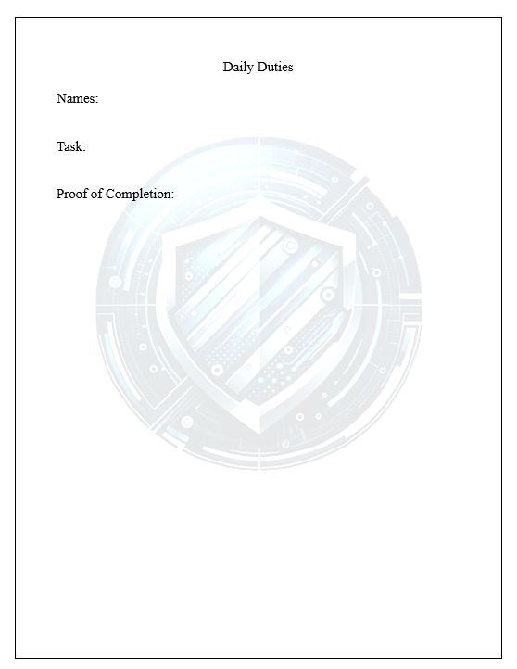

This is where you will document your steps and paste your screenshots for points.

It is encouraged that you also copy and paste the “Task: and Proof of Completion:” Multiple times below for your injects

It is your team’s responsibility to record keep. Your boss/manager is not going to respond to every inject immediately, so DO NOT submit a form for every inject.

You are not allowed to asked what injects were submitted

You are not allowed to modify injects after submission, unless given permission to do so

Failure to follow these rules may result in loss of points.

Daily Duties can also include ethical and professional challenges unexpected during the competition. Logging those here can result in bonus point at the operator’s discretion

For task, you want to include the inject title and potentially the inject number for record keeping.

Unless stated otherwise, everyone’s name should go on the names section. Team names are acceptable as long as the operator or instructor knows who is on what team. Failure to do so will result in loss of points.

# Using the Justifications Form

Arguing is reserved for the justification form. Justification forms can be submitted in lieu of completing a task or inject. Teams can refuse to do an inject for a myriad of reasons, but the justification form is reserved for legitimate ethical and professional reasons. Should a justification form be approved and properly structured and submitted, the team may be awarded full points, half, or a determined amount by the operator. Reasoning for approval or denial will be returned to the team on the same justification form. At that point, questioning the form in the competition is not allowed, except for extreme cases of disagreement between the team and the operator. In that case, the operator may call upon a 3rd party to make the final call. After the competition time (or the completion of the competition as a whole) questions may be asked in a student-teacher manner. **IMPORTANT:** Should a team decide to submit a justification form and the team captain submits it, they are not able to complete the current inject that they submitted the justification form for. Approved or denied. Should it be included on the daily duties it may result in loss of points. Teams CAN still complete the task, should it be denied or approved, and they decide the action still benefits them, but they cannot receive points for completing it. Arguing about the outcome of a justification form can result in the team being disqualified. Arguing within the team after the results or during discussion about a justification form can result in immediate disqualification if the operator finds it to be detrimental to the competition environment.

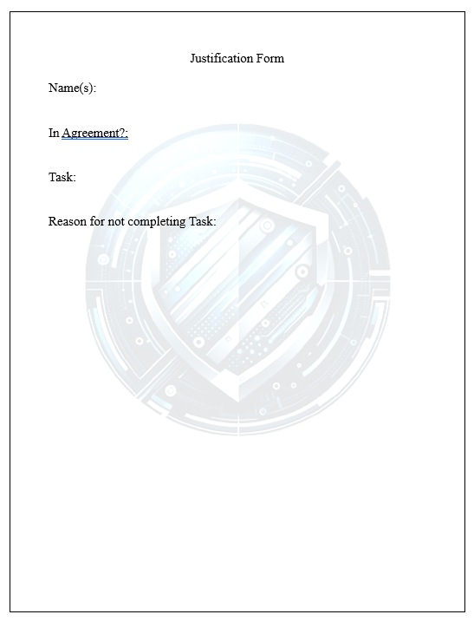

Similar to the daily duties, the team will input their reasoning here. It is advised that students be open and honest about their reasoning and use professional language and justification.

Whether ethical or professional, teams do not have to state specifically, it should be understood through their communication.

IMPORTANT: SUBMIT 1 JUSTICATION FORM FOR 1 INJECT

DO NOT PUT MUILTIPLE INJECTS ON ONE FORM (this is more for the teams than the scorer…)

It is advised to also keep a copy of each justification form for the team’s record

For task, you want to include the inject title and potentially the inject number for record keeping.

The Team Captain or designated submitter may submit this form. The team must decide whether or not they all agree with not completing the task, or if there were disagreements. A simple yes or no suffices here, but more details may be useful for the team. As the operator reserves the rights to question it.

Unless stated otherwise, everyone’s name should go on the names section. Team names are acceptable as long as the operator or instructor knows who is on what team. Failure to do so will result in loss of points.

Justification forms offer a challenge for ethics and professionalism. It is not advisable to simply follow every command given, but really consider the task at hand coupled with your knowledge and the research available to you.

Gameplay

You and your team have been given specific devices with the intent that they will harden them while performing business injects. It is advised that the team reads injects carefully. Injects are delivered to the team captain and it is the captain’s responsibility to disseminate that information. Teams are to abide by the rules listed above and may keep the Rules of Engagement handy unless replaced by something else or specifically denied this option.

Over the specified time, your team is to work together collaboratively, effectively, and while showing sportsmanlike conduct towards other teams as well as professionalism towards each other. Failure to do so can result in disqualification. The competition does not take into account every single detail, this is intentional as the work world has to adapt to everything as it comes. Your operator may be monitoring your teamwork, they may also take note of actions done by the team within the competition time and after it. It is the team captain’s responsibility to keep their USB drive safe, failure to do so, may result in lost work and/or lost secrets. USB drives are non-replaceable. Should they go missing, unless for valid reasons (drive failure, acts of God, acts of nature) they will not be replaced.

Submit injects through the specified portal/method (INSTRUCTORS INSERT SECIFICED PORTAL/METHOD HERE) as well as justification forms. You should submit 1 daily duties form for ALL injects and work performed that day. You should submit 1 justification form for EACH inject as needed.

Scoring is based on the rubric below:

|  |  |  |  |
| --- | --- | --- | --- |
| Category | Description | Points Possible | Points Earned |
| Completion of Injects | *Was the task completed? If so, award full points. If justification was used to not complete the task, if sufficient and legitimate award full points. If not, award determined points.* | 750 |  |
| Quality of Injects | *Was the task properly documented? Proper documentation is defined as, descriptive enough that a new hire (not intern) could follow the steps and achieve either the same results or replicate positive results for auditing. Was the justification form filled out properly? Award full points if yes.* | 750 |  |
| Sub Injects | *Were the sub injects completed properly? Sub injects are at more of the discretion of the operator than regular injects, they serve to help break ties and challenges the team beyond the norm.* | 300 |  |
| Teamwork | *Instructor Observation, entirely determined by the operator. Considering 360 feedback is entirely optional, and does not have to be stated prior.* | 200 |  |
| Total Score |  | 2000 |  |
| Notes |  | | |

Descriptions are expectations within the categories but may not reflect all of the values used to score your team. Operators may include more information in the notes section.

Each team member is required to fill out a 360-feedback form at the conclusion of the event. This is to be done alone and anonymously. 360 feedback forms MAY or MAY NOT be used for scoring, this is the operator’s discretion. They reserve the right to not let you know if it will or will not be used. 360 feedback forms are to be used professionally, not as a means to tear a team member down. It is fair to mention difficulties as well as issues, negative 360 feedback forms WILL NOT impact scores. Honesty will. 360 feedback forms are to be anonymous to each other but you must put your name at the top when submitting it to your instructor. Failure to do so will result in the form being thrown out and the team failing to meet the final request, the fallout of this is operator’s discretion.

Students are to adhere to the rules and layout listed above. If you have any questions, now is the time to ask your instructor. If you agree and are prepared to compete. Sign this form below, date it and send it to the appropriate party.

Name; _______________________________________________________________________________

Date: _________________________________________

Signature:

|  |
| --- |
|  |

Thank you

We hope you enjoy the I2CCDC!